PAPER 2 TOPIC REQUESTS
TOPIC
X
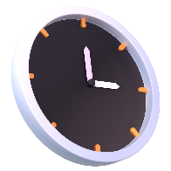
TIME TO COMPLETE: 1 HOUR

Highlight or otherwise indicate what content subpoints you’d like us to go back over during our paper 2 review session. I can’t promise I’ll get to all of it, but I’ll do my best. The course guide can be found on GitHub, search for “Option A” to find the database content.
Read over the case study, also on GitHub, and do the same thing.

